**IBM CLOUD VIDEO STREAMING PROJCT**

CHANNEL NAME: STEP TO TECH

Introduction:

Introducing [IBM cloud video streaming application] - Your Gateway to Limitless Entertainment!

Are you tired of limited content options and endless buffering? Look no further! We're thrilled to unveil the hottest video streaming application in town, [step to tech]! With a seamless user experience and a vast library of diverse content, we're redefining how you experience entertainment.

Why [IBM- step to tech]

1. Unparalleled Selection: Dive into an extensive catalog of movies, TV shows, documentaries, and exclusive original series spanning across genres and languages. From Hollywood blockbusters to indie gems, we've got it all!

2. Buffer-Free Streaming: Say goodbye to those frustrating loading screens! Our advanced technology ensures uninterrupted, high-definition streaming even on slower connections.

3. Personalized Recommendations: Our intelligent algorithm learns your preferences to curate a tailored viewing experience. Discover hidden gems you never knew you'd love!

4. Multi-Device Accessibility: Watch your favorite content anytime, anywhere! Whether you're on your smartphone, tablet, laptop, or smart TV, we've got you covered.

5. Download and Go: Planning a trip? Download your favorite shows and movies to watch offline, perfect for those long flights or remote getaways.

Here's how to get started:

1. Visit Our Channel Page: Head over to our channel page on [IBM video streaming] by [https://video.ibm.com/channel/5mj2MD54MLG].

1. Sample of video streaming ,thus the program will execute by the given model

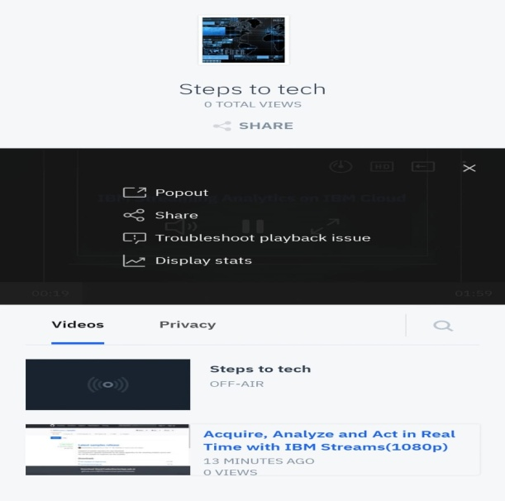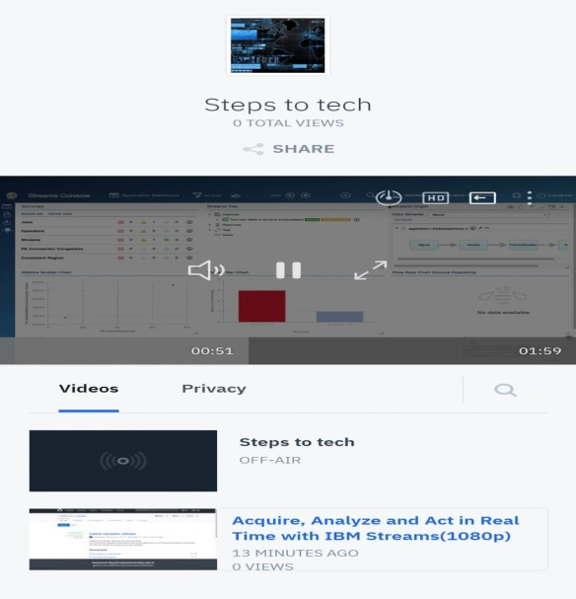

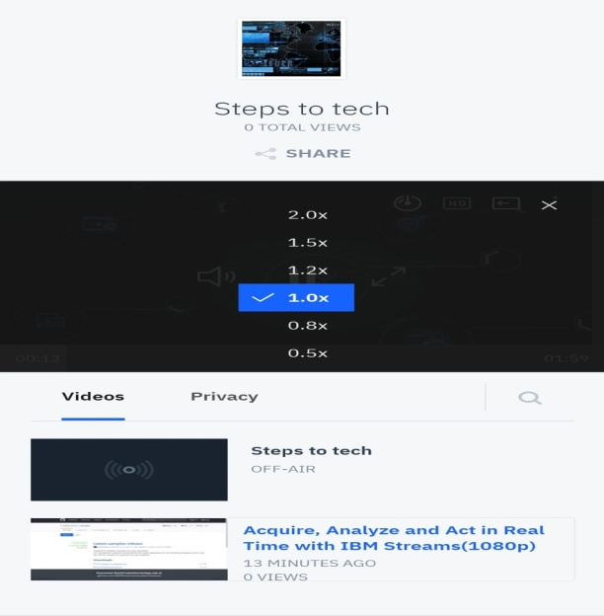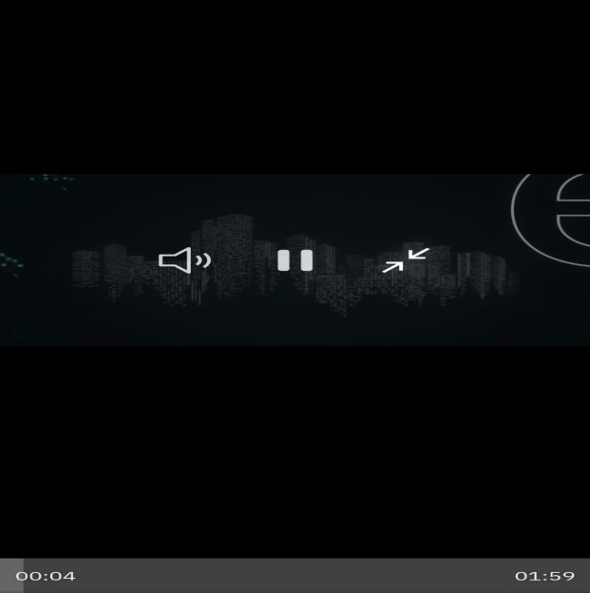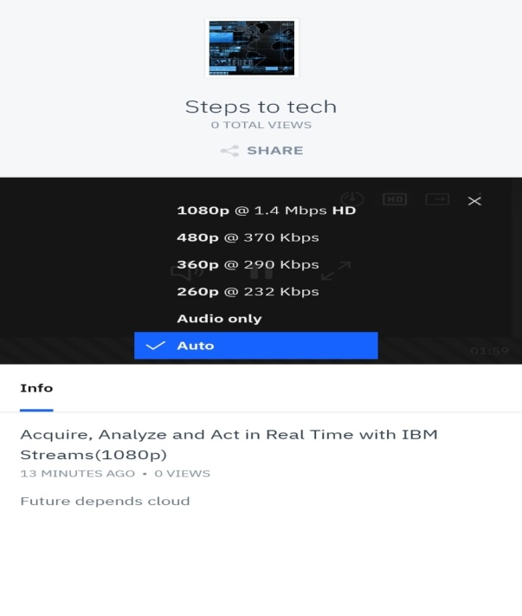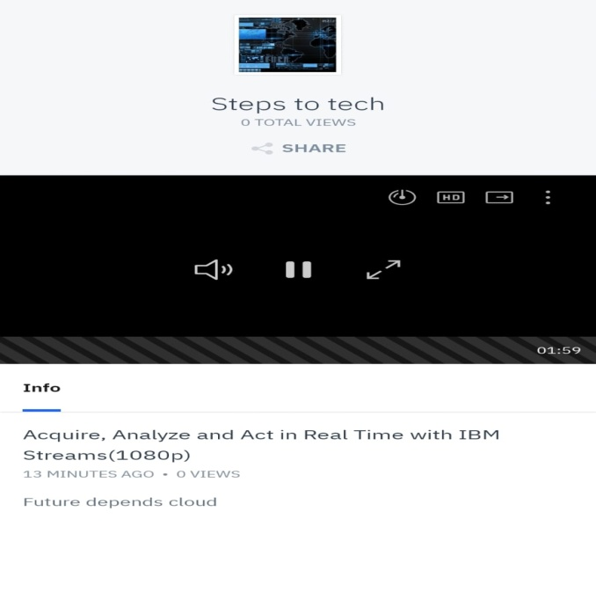

You can access by the web link: <https://video.ibm.com/channel/5mj2MD54MLG>

Ibm platfor by integrating video streamin services and enabling on demand playback.

It has been created by the functionallyties of users can upload their movies and vedios to the platform.

Integrated IBM cloud videos streaming services to enable smooth and high quality video playback.